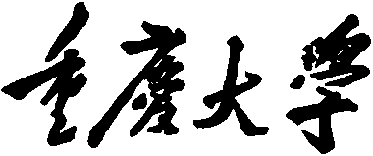 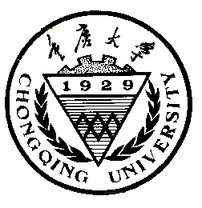

**Personal Learning Portfolio**

**Course： English Academic Writing Teacher： Zhang Mei**

**Class： 002 Major： Computer Science**

**Name： Wen Hongbing Student Number： 20214590**

**Class Time： 2023.02-2023.07**

**Grade：**

|  |  |  |
| --- | --- | --- |
| **Self** | **Teaching Assistant** | **Teacher** |
|  |  |  |

**Comments：**

**Teacher (Signature)**

**Contents**

**Week 1**

1. **My learning**

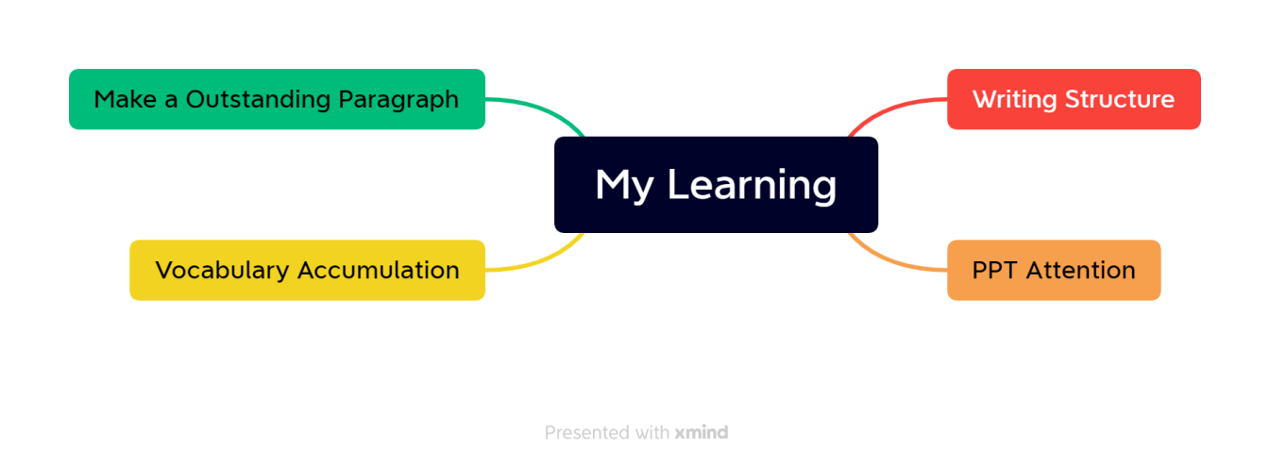

1. **Learning outcomes**

In this week's class, I learned some basic knowledge about writing and making ppt, such as the basic framework of the paper, the main framework of the essay, the focus of writing, and the main color of ppt making should be sunny and cheerful, so as not to leave a negative first impression on people.

Besides, I also learned a lot outside class, such as the specific classification of a sentence and its related functions, the standards that an excellent paragraph should have and how to write an excellent paragraph. In addition, I also completed vocabulary accumulation on time and reviewed the old and learned new things.

In the future when making ppt, I will pay special attention to the overall tone; In the future writing work documents will have a focus to write; When sending invitations or other important letters, pay special attention to unity, coherence and Transition.

1. **My behavior and attitude**

After class, I accumulated vocabulary independently and finished my homework on time on Saturday night. I spent an afternoon feeling good about myself and taking my homework seriously. Above class, poor performance this week, entering college taking few notes, lack of concentration.

1. **Improvement**

Should improve the attention in class, treat the class seriously, actively answer questions, do a good job in class notes to facilitate the review of income.

**第3和第4点可以从以下方面去考虑：**

**1）Out of Class**

1.1 Autonomous learning（Online + Offline）

1.1.1Online（MOOC or other platform online）

1.1.2 Offline（listening, speaking, reading, writing, translation）

1.2 Homework (on time; not leave your homework until deadline; serious attitude)

1.3 Cooperative learning（group discussion，making PPT，as a group leader，etc.）

**2）In Class**

2.1 Individual performance (Concentration, taking notes, questions and answers, comments).

2.3 Cooperation (Classroom discussion, Classroom presentation and performance)

Tips：

1）Innovation is encouraged in the form of writing.

2）Listen carefully and take notes.

3) Summarize every week!

**每周用英语总结，包含以上四个方面(去掉老师的解释和说明)，17周必须提交，满分10分。**